**Git vs Github**

Git is a tool a developer installs locally on their computer, while GitHub is an online service that stores code pushed to it from computers running the Git tool.

Git is an open-source tool developers install locally to manage source code, while GitHub is an online service to which developers who use Git can connect and upload or download resources.

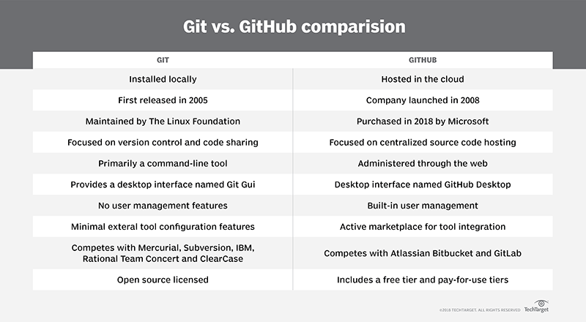 **Note**:- Git competes with centralized and distributed version control tools such as Subversion, Mercurial, ClearCase and IBM's Rational Team Concert.   
On the other hand, GitHub competes with cloud-based [SaaS](https://searchcloudcomputing.techtarget.com/definition/Software-as-a-Service) and PaaS offerings, such as GitLab and Atlassian's Bitbucket.  
  
  
**Comparison Table:-**  
  
  
  
**Why these cloud version needs to introduce ?**Git doesn't provide any out-of-the-box features for authenticating users against a centralized credentials repository, nor does it provide the ability to protect blessed master branches from inadvertent commits by an unwitting developer.  
This is where vendors such as **GitLab**, **Atlassian** and **GitHub** enter the picture.

# **GitHub vs. Bitbucket vs. GitLab**

Git for the version control software (VCS) itself, but the platform where the code lives is equally important.

GitHub offers free public repositories.  
Bitbucket also offers free private repositories.  
GitLab offers a Community Edition which is entirely free.  
  
**What is Bitbucket?**

Bitbucket gives teams one place to plan projects, collaborate on code, test and deploy, all with free private Git repositories. Teams choose Bitbucket because it has a superior Jira integration, built-in CI/CD, & is free for up to 5 users.

**What is GitHub?**

GitHub is the best place to share code with friends, co-workers, classmates, and complete strangers. Over three million people use GitHub to build amazing things together.

## **What is GitLab?**

GitLab offers git repository management, code reviews, issue tracking, activity feeds and wikis. Enterprises install GitLab on-premise and connect it with LDAP and Active Directory servers for secure authentication and authorization. A single GitLab server can handle more than 25,000 users but it is also possible to create a high availability setup with multiple active servers.

**Which one is better to use :-  
  
Point 1:-** GitHub is focused around public code, and Bitbucket is for private.  Basically, GitHub has a huge open-source community, and Bitbucket tends to have mostly enterprise and business users.  
That’s not to say that you can’t have a private repository on GitHub (you can). Or that you can’t post your code publically on Bitbucket (again, you can).

Because Bitbucket is an Atlassian product (the makers of [Trello](https://www.elegantthemes.com/blog/resources/trello-an-in-depth-overview-and-use-case-recommendations) and other apps), you have a slick and clean interface from the moment you log in. You see immediately that they’re focused on professional teams as an all-in-one solution for software development. Let’s see how.

**Point 2:-**  GitHub, obviously, is a hub for git version control. BitBucket, on the other hand, supports more than just git. You can also track your repositories in [Mercurial](https://www.mercurial-scm.org/), another popular version control management system. It does not support SVN, another major system, but at least with Bitbucket, you have a choice.  
  
**Point 3:-** Using Bitbucket’s website is just wonderful. It’s easy and simple, and you always know what’s going on. GitHub’s website works, but it’s not always clear as to what you need to do to accomplish certain things.

**Point 4:-** One area that is surprisingly absent from Atlassian’s Bitbucket is a desktop client (GitHub makes one, though). If you go with Bitbucket, you will not get a first-party one, but rather, an open-source program called “[Sourcetree](https://www.sourcetreeapp.com/)”.  
  
**Point 5 :-** In what used to be Bitbucket’s strongest selling point, GitHub now offers unlimited **free** private repositories. Previously, only public repos could be created for free, and private ones were for paying members only. Now, however, you can create as many as you want, totally for free. The catch, though, is that you can only have 3 contributors to the repo (not counting yourself). So if you’re on a large team, you’re going to be paying, regardless.

**Main Point :-**   
A benefit of GitHub is that you don’t get charged for that storage. Even on a free plan. There is a hard [100-gigabyte cap on GitHub repositories](https://help.github.com/en/articles/what-is-my-disk-quota), though they recommend it being under 1gb (which many of them will be). The file uploads are limited to 100mb for command line and 25mb for web uploads.

Bitbucket, though, only allows free users 1gb total. Instead of requesting that you keep it below 1gb and then emailing you when you reach 75 (which is a very large range and kind of an odd choice), Atlassian pushes you toward the paid plans at 1+gb.

## **GitLab vs GitHub**

**Point 1:-** With GitLab you can set and modify people’s permissions according to their role. In GitHub, you can decide if someone gets a read or write access to a repository.

**Point 2:-** GitLab offers its very own CI for free. GitLab is addressing the topic of Auto CI and how to automatically run CI/CD without a human being actually setting it up.

GitHub offers various 3rd party integrations – such as Travis CI, CircleCI or Codeship – for running and testing your code. However, there’s no built-in CI solution at the moment.

**GitLab is particularly popular among larger development teams.**

**Important link to work in Editors with the GIT**

[**https://www.youtube.com/watch?v=Fk12ELJ9Bww**](https://www.youtube.com/watch?v=Fk12ELJ9Bww)

[**https://www.youtube.com/watch?v=X9-iaXfKY5g**](https://www.youtube.com/watch?v=X9-iaXfKY5g)

**Interview Question:-**<https://www.edureka.co/blog/interview-questions/git-interview-questions/>